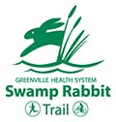
Examples Of Successful Greenway Projects
Swamp Rabbit Trail, North Greenville
The trail is a multi-use greenway system that runs along the Reedy River connecting Greenville County with schools, parks, and local businesses. A large portion of it runs along old rail bed between Greenville and Travelers Rest. The trail is an excellent example of how creating a trail can modify physical activity, recreation and transportation behaviors while contributing to local economies. Property values have increased 15%, and trails rank in the top five important amenities in making real estate purchase decisions.
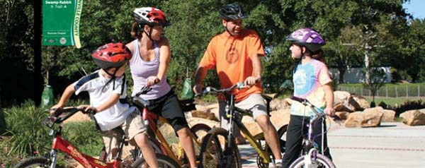

Falls Park on the Reedy, Greenville SC
Building on the master plan designed in 1999 by landscape architect Andrea Mains, Falls Park was developed to include 20 acres of gardens showcasing Reedy River Falls. In 2002 the city committed funds to transform the park into a public garden and oasis. With the addition of the Liberty Bridge, the park has become a focal point for Greenville.
https://www.greenvillesc.gov/167/Falls-Park
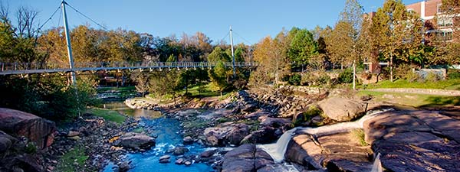

Little Sugar Creek, Charlotte NC
For a case study in how an project reclaimed a blighted urban waterway and made a major positive impact on a community, see the story of the Little Sugar Creek Greenway in Charlotte. Parking lots were converted into vegetated natural buffers that improve water quality, reduce the impacts of flooding, and provide wildlife habitat. Greenway trails provide recreation, transportation, fitness, and economic benefits for all to enjoy.
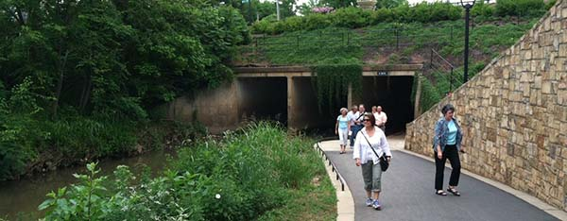

San Antonio River Walk, San Antonio TX
A number of folks have mentioned the San Antonio River Walk in Texas as an example of what might be done with the Crowson Road area of Gills Creek. The River Walk started development in the 1930’s, was upgraded in the 60’s, and is now the number one tourist attraction in Texas. The San Antonio River Walk is a public park open 365 days a year, lined with individual businesses composed of restaurants, hotels, attractions and more.
